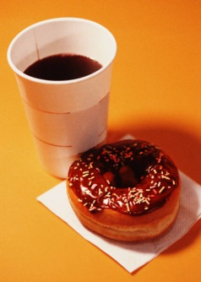Snacks in

In the Library

Monday, 4/2

8am- Noon

______________

See new purchases,

suggest new resources,

and have a snack!

the Stacks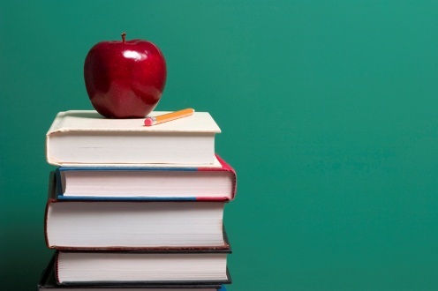

Snacks in

In the Library

Monday, 4/2

8am- Noon

______________

See new purchases,

suggest new resources,

and have a snack!

the Stacks